**m.s.sanjay**

**15bce0517**

**Microprocessor and Interfacing**

**Lab Experiment 8**

**Traffic light signal simulation**

**Code:**

#start= Traffic_Lights.exe#

label:

mov ax,06DBh ;all red and yellow

out 4,ax

mov cx, 4Ch ; for delay of 5 seconds

mov dx, 4B40h ; 004C4B40h = 5,000,000

mov ah, 86h

int 15h

mov ax,071ch ; vertical is green

out 4,ax

mov cx, 4Ch ; for delay of 5 seconds

mov dx, 4B40h

mov ah, 86h

int 15h

mov ax,06DBh ;all red and yellow

out 4,ax

mov cx, 4Ch ; for delay of 5 seconds

mov dx, 4B40h

mov ah, 86h

int 15h

mov ax,08E3h ; horizontal is green

out 4,ax

mov cx, 4Ch ; for delay of 5 seconds

mov dx, 4B40h

mov ah, 86h

int 15h

jmp label ;jumping to start...

SCREENSHOTS

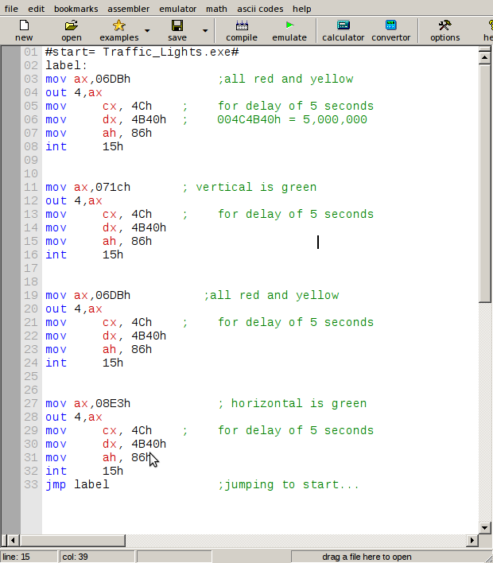

SITUATION 1: All are red and yellow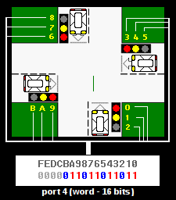

SITUATION 2: Vertical signals are green

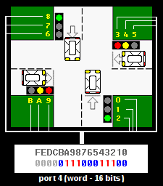

SITUATION 3: All are red and yellow



SITUATION 4: hotizontal are green

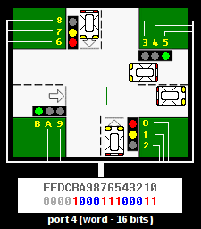

and then in loop........